Module 2: EC2 and EFS Assignment

Tasks To Be Performed: 1. Create an EFS and connect it to 3 different EC2 instances. Make sure that all instances have different operating systems. For instance, Ubuntu, Red Hat Linux and Amazon Linux.
Created three instances:
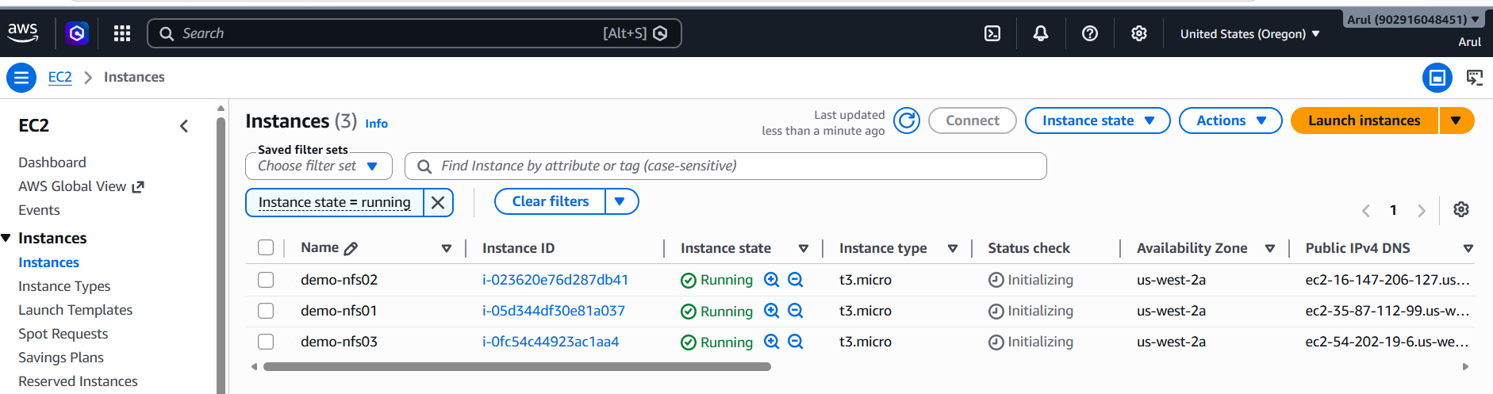

Creating NFS:
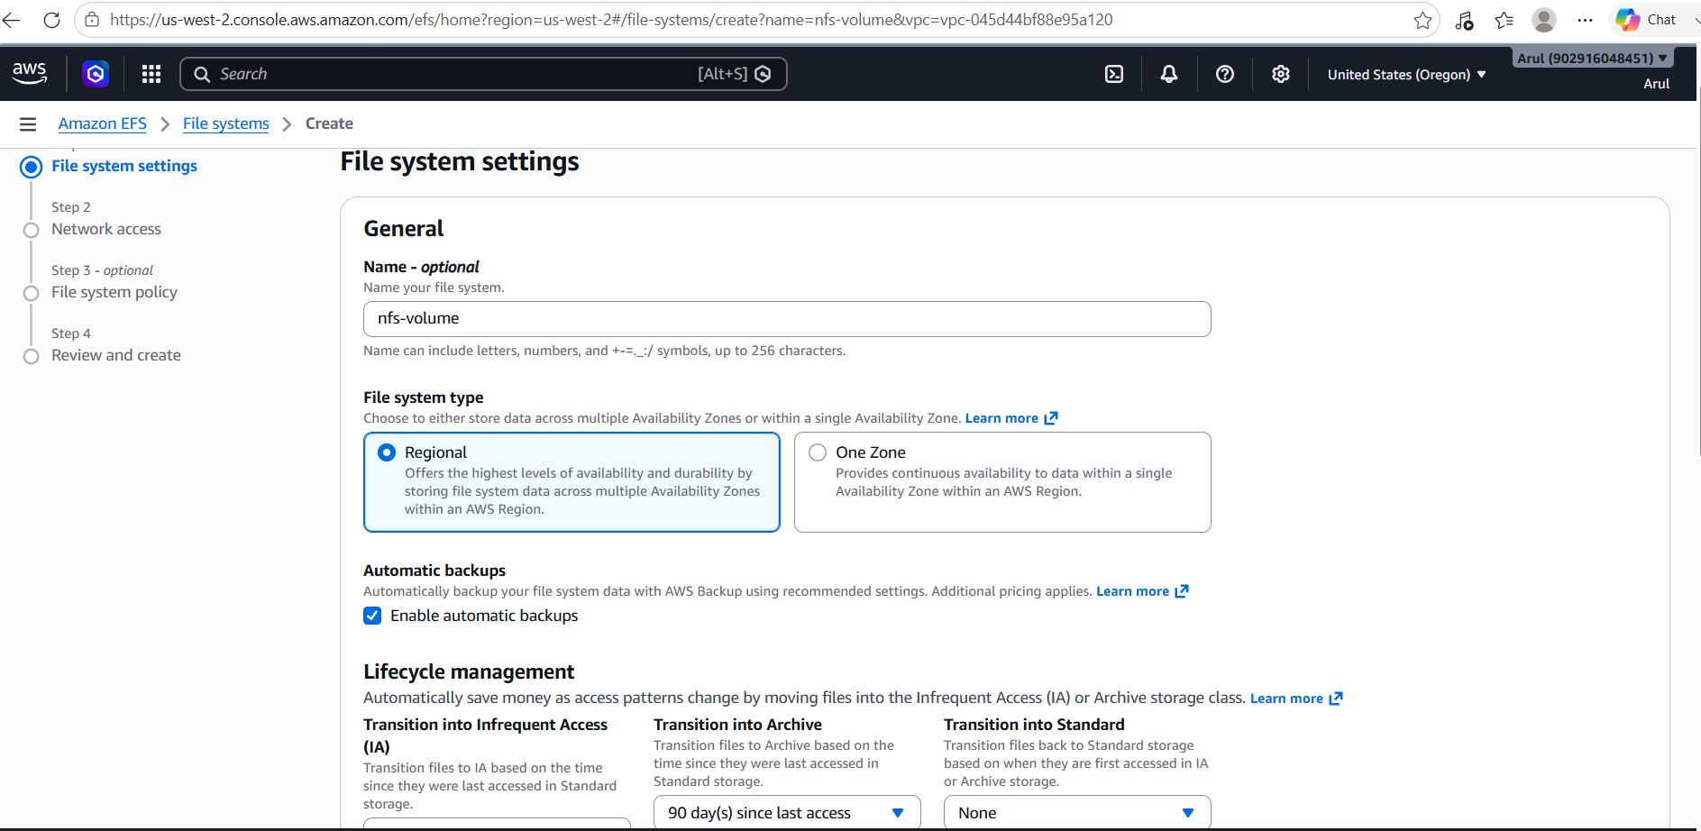

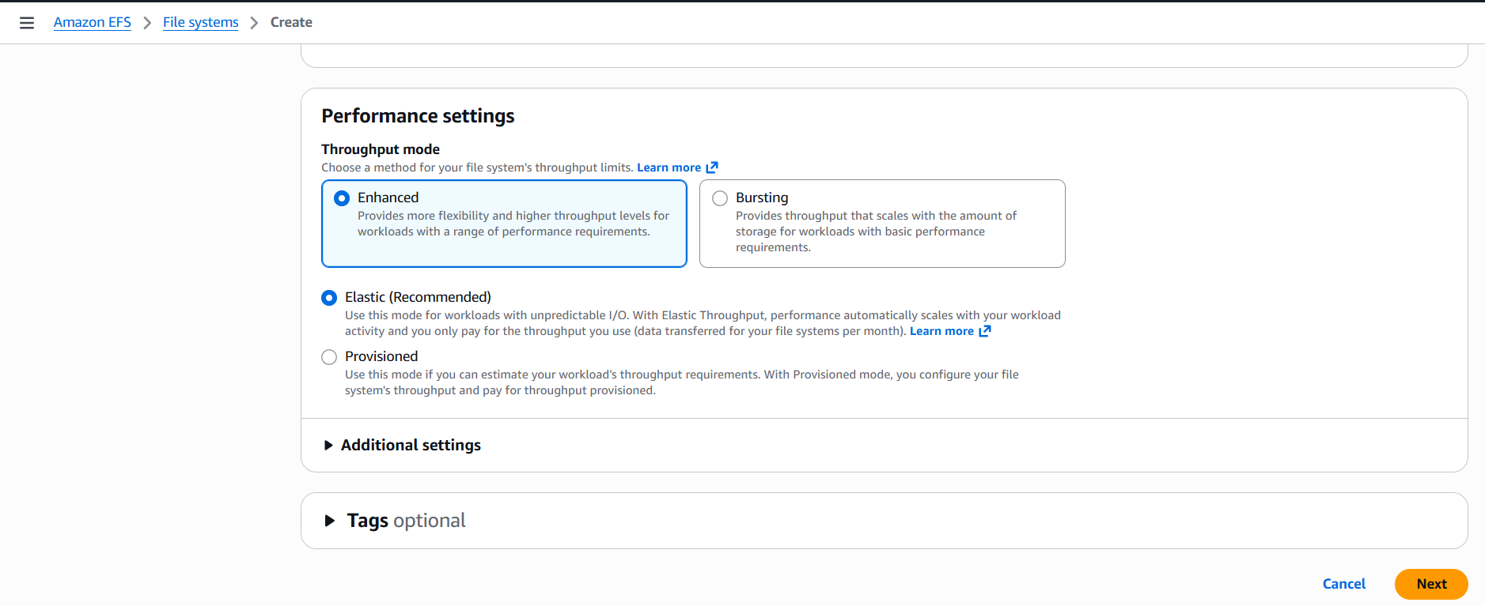
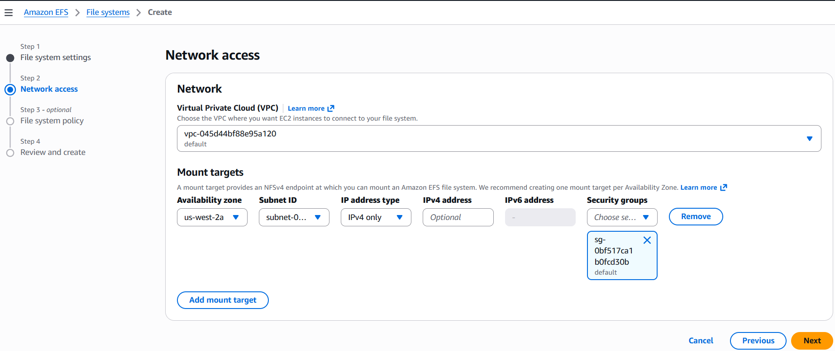
NFS created with the ID: nfs-volume (fs-0643088a79bcd47fb)
DNS name: fs-0643088a79bcd47fb.efs.us-west-2.amazonaws.com
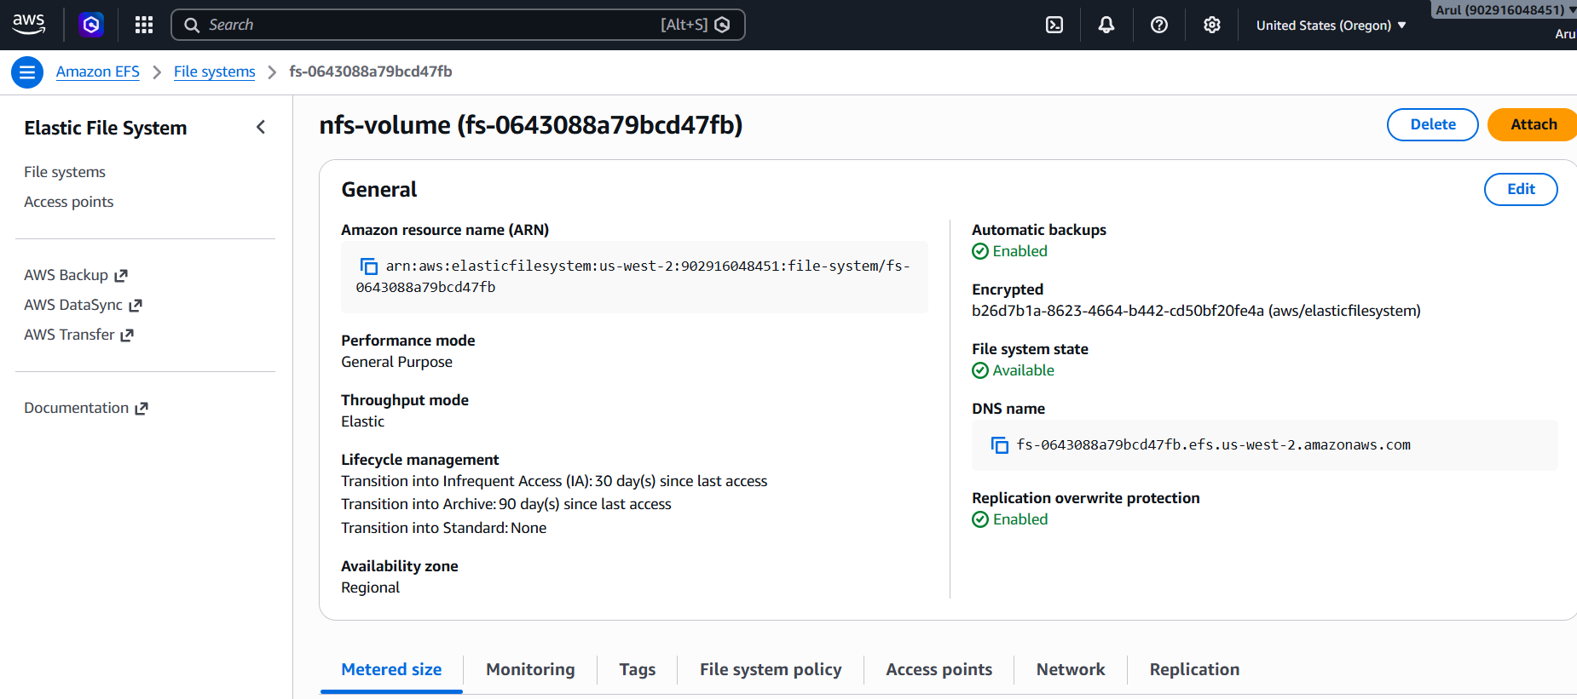

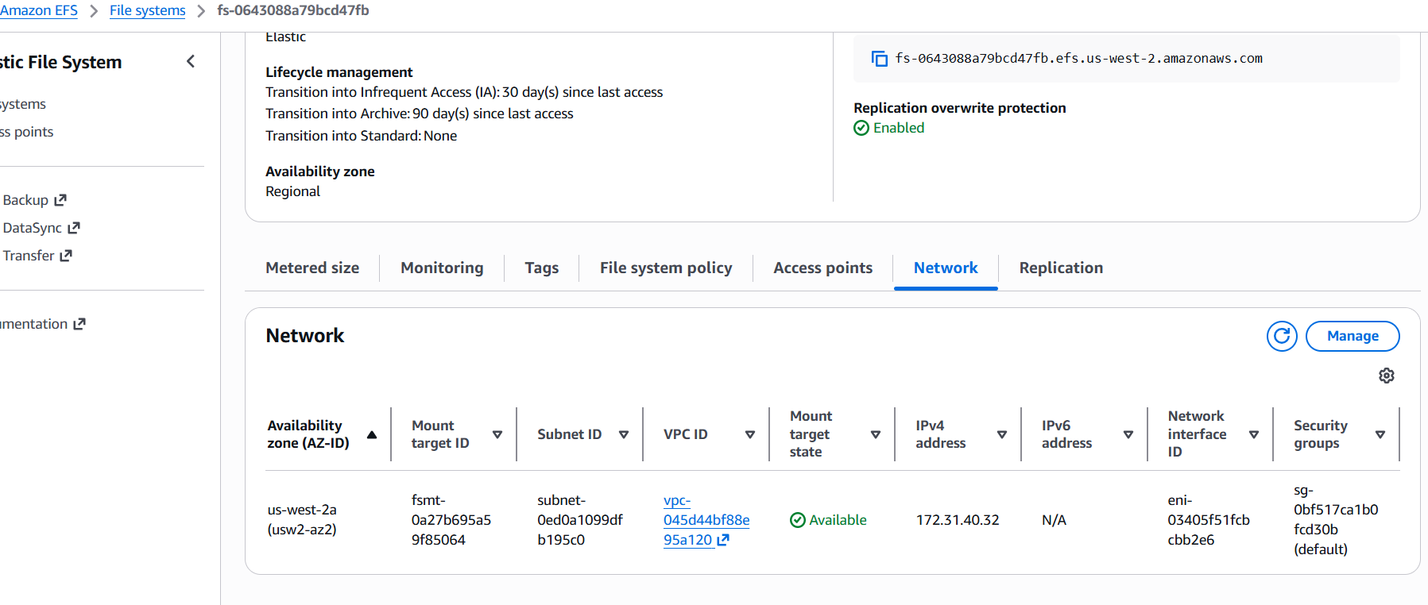

EC2 – ssh port is enabled:

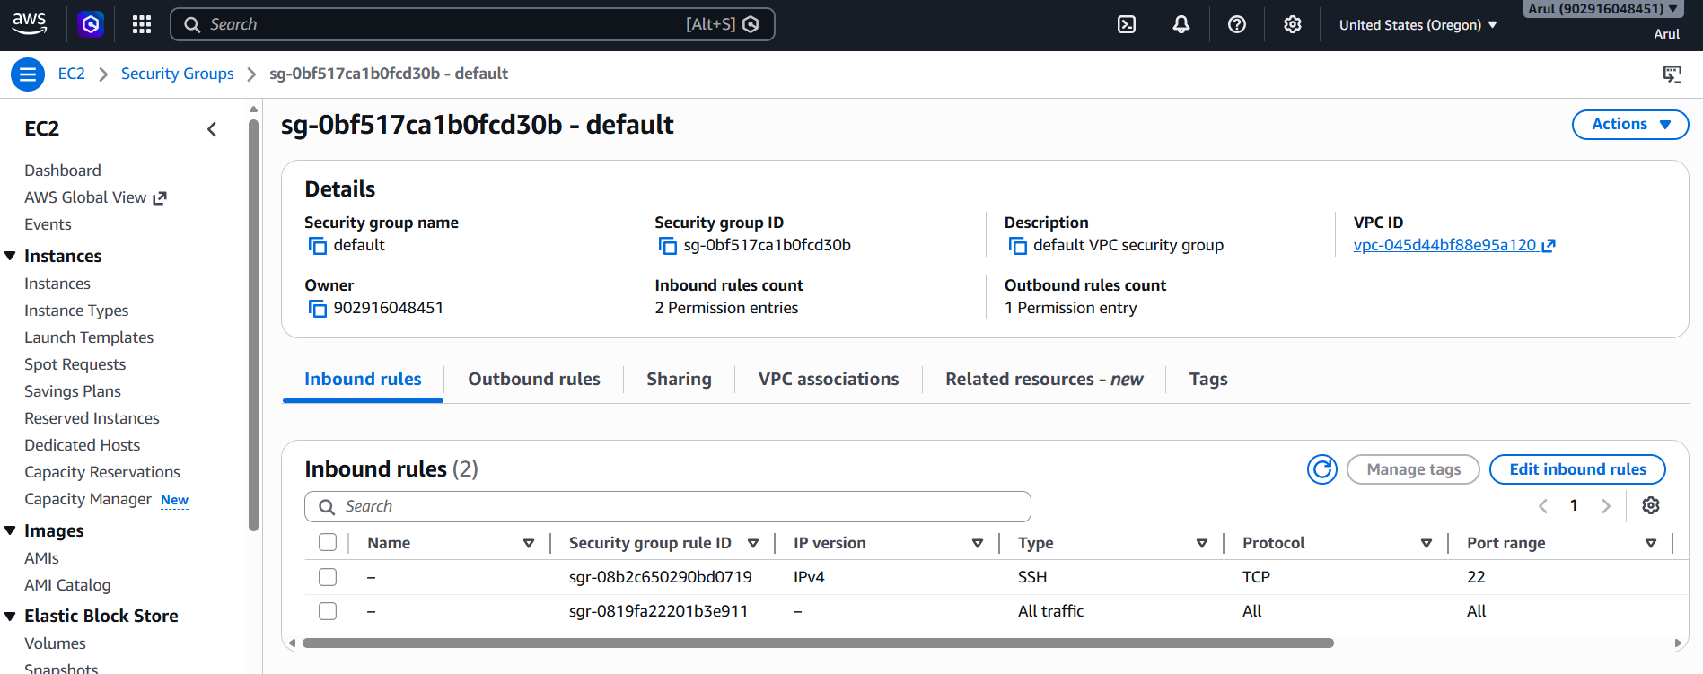

NFS mount on demo-nfs1 server: (changed the name of the server at OS level)
DNS name: fs-0643088a79bcd47fb.efs.us-west-2.amazonaws.com
Local mount: nfs1
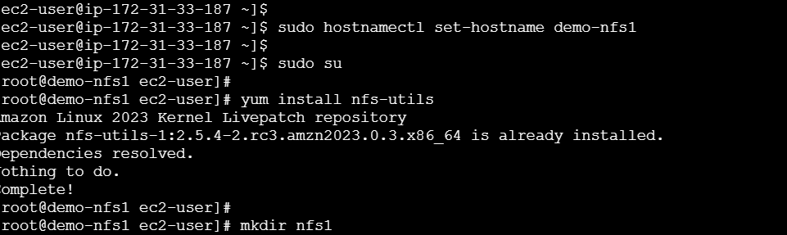
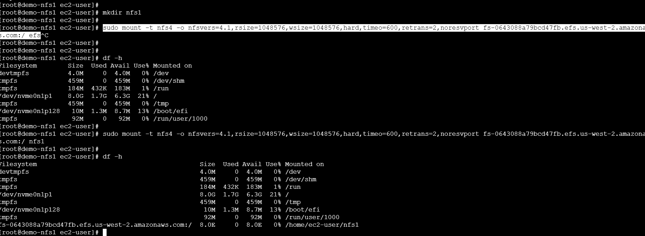
NFS mount on demo-nfs2 server:
DNS name: fs-0643088a79bcd47fb.efs.us-west-2.amazonaws.com
Local mount : nfs2

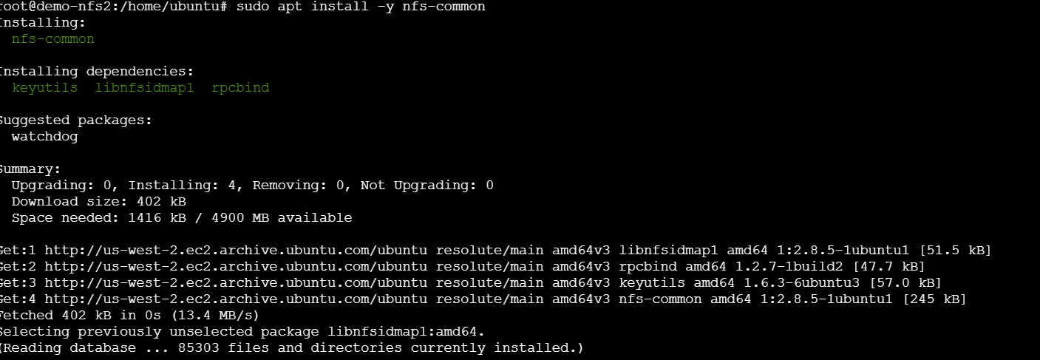
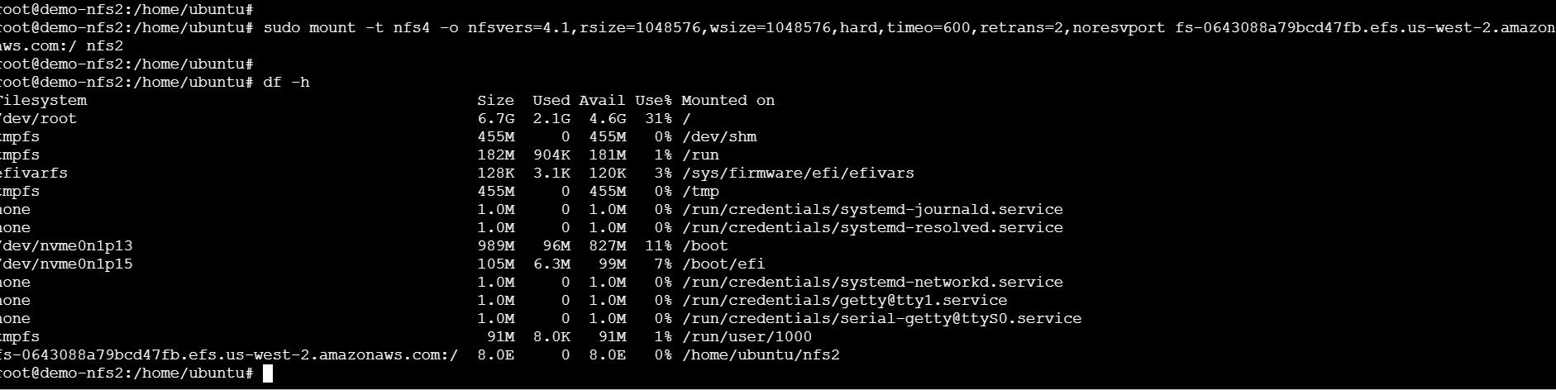

NFS mount on demo-nfs3 Server:
DNS name: fs-0643088a79bcd47fb.efs.us-west-2.amazonaws.com
Local mount: nfs3
